***Instructor Documentation***

1. **Sign Up**: User need to register themselves as instructor by clicking on the website “Sign Up” button.

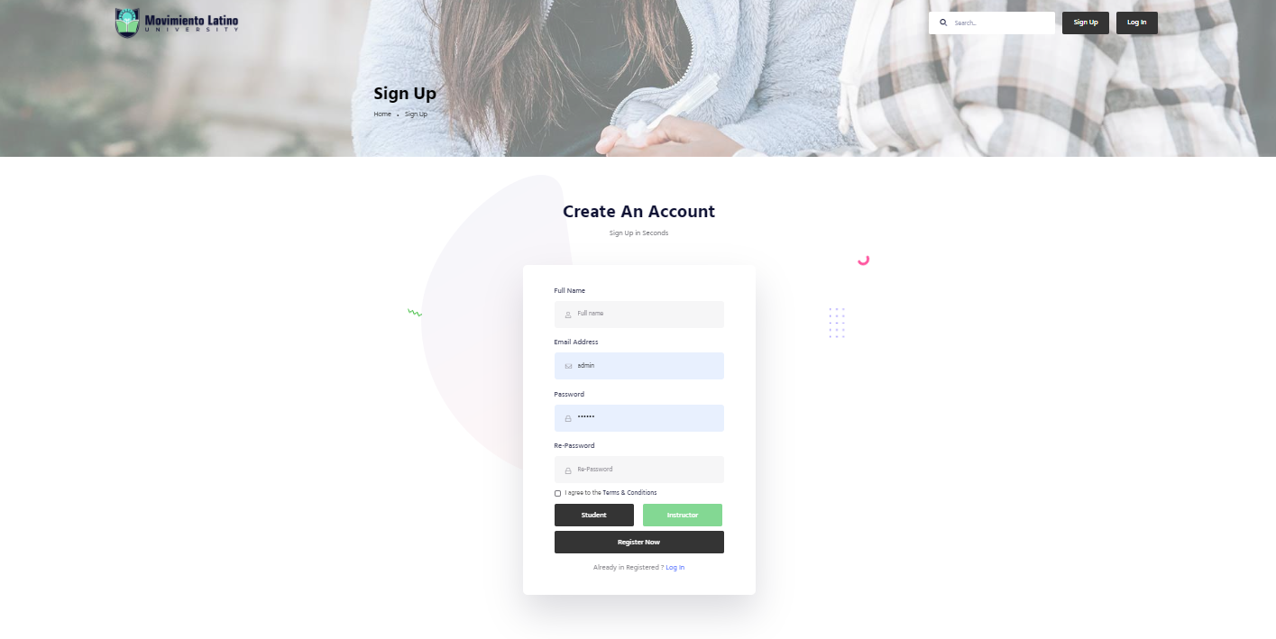

1. **Sign In**: User need to put valid credential for sign in to the website.



1. **Instructor Dashboard**: After successful login user will redirect to the specific dashboard.

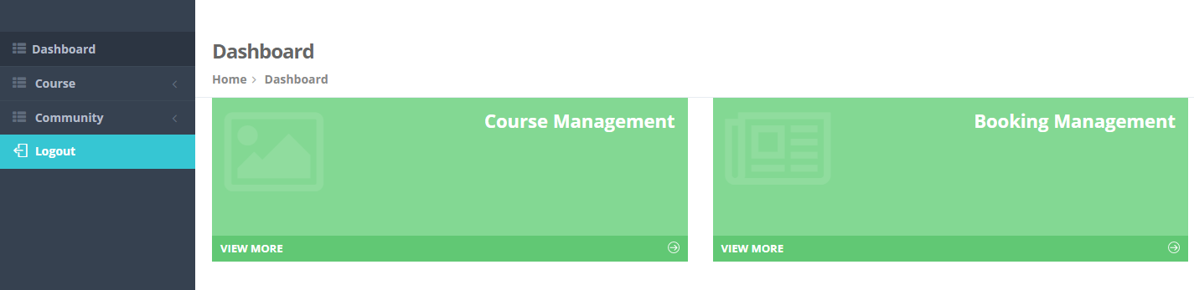

1. **Course Management**:
2. **Add Category**: Instructor need to add category, which will be shown as dropdown in add course page.

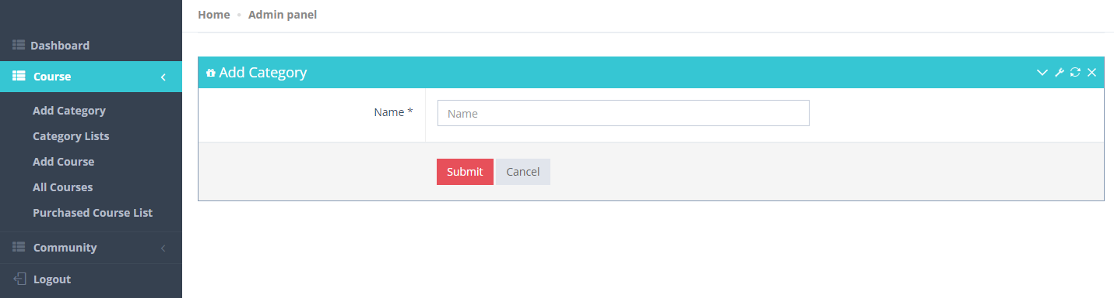

1. **Category List**: All the added category will be listed here. From where instructor can edit/delete each category.

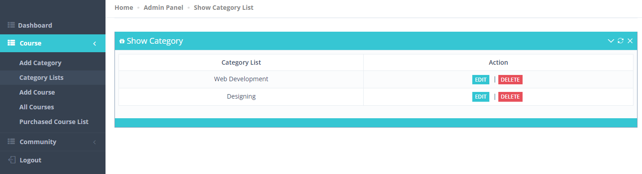

1. **Add Course**: Instructor can add course by filling add the necessary fields. While adding the course Instructor can choose the course price. If the course price is set to **Paid** Instructor will get to put the price and the **Stripe Price ID.**

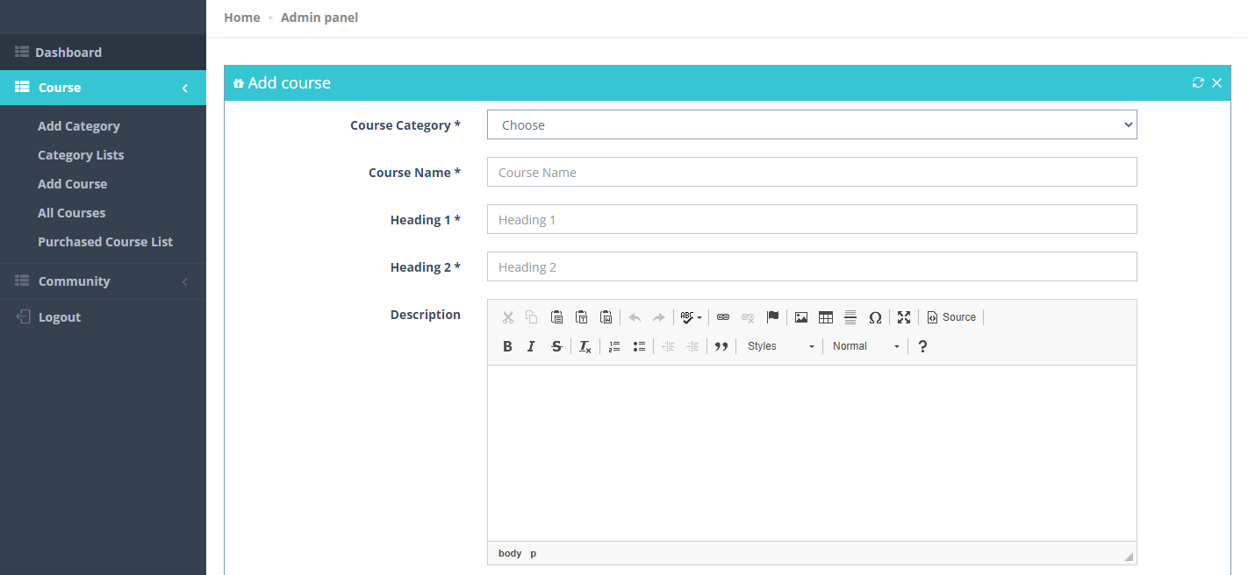

1. **Course List**: All the added course will be shown in the list. From where Instructor can edit/update and delete course.

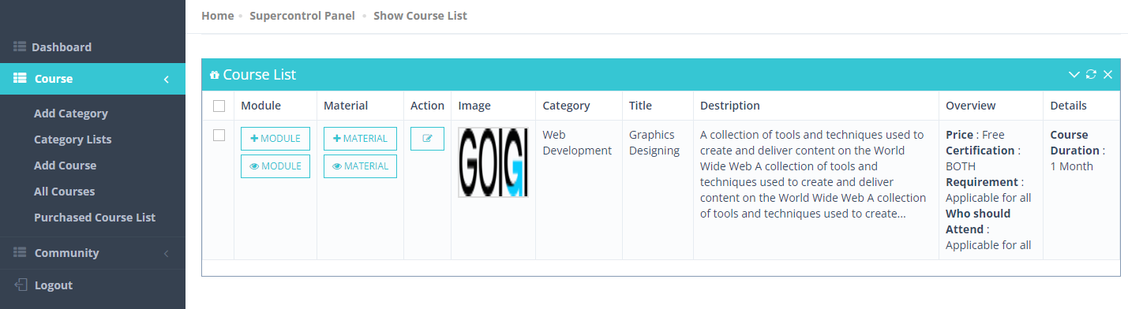

1. **Module (In Course List)**: Instructor can add module for every course by clicking on the “+ Add” button for every course.

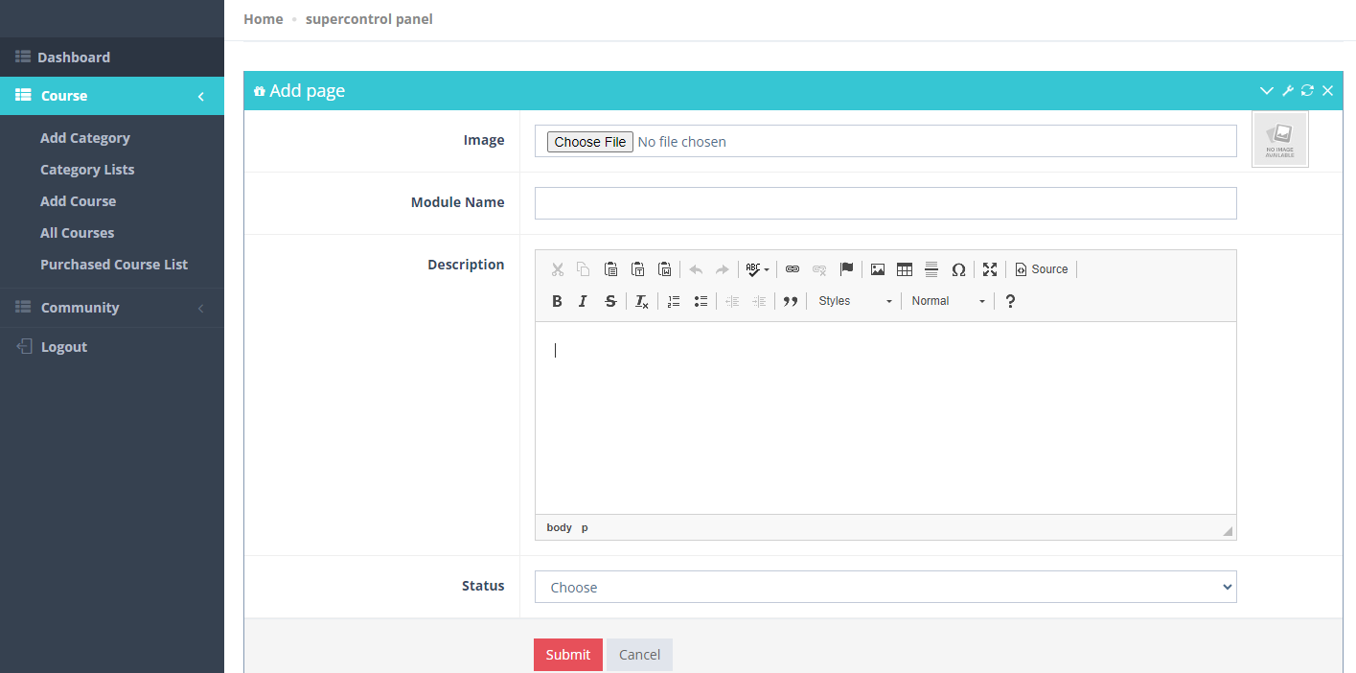

1. **Module List**: After adding module for a particular course, it will appear in the Module list. Also Instructor can view module for each and every course by clicking on “View” button from the course list.

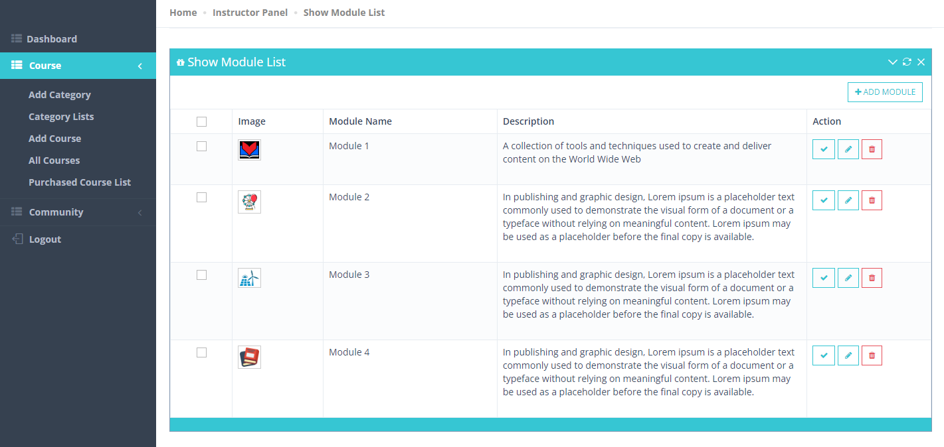

1. **Material**: Instructor can add material for a particular module by clicking on the “Material Preference” from course module list or from the course list page. If Instructor want to add material from the course list page, it will be redirect the to the add material page, from where Instructor need to choose “**Module Name**” & “**Material Type**”. Please see below screenshot for options.

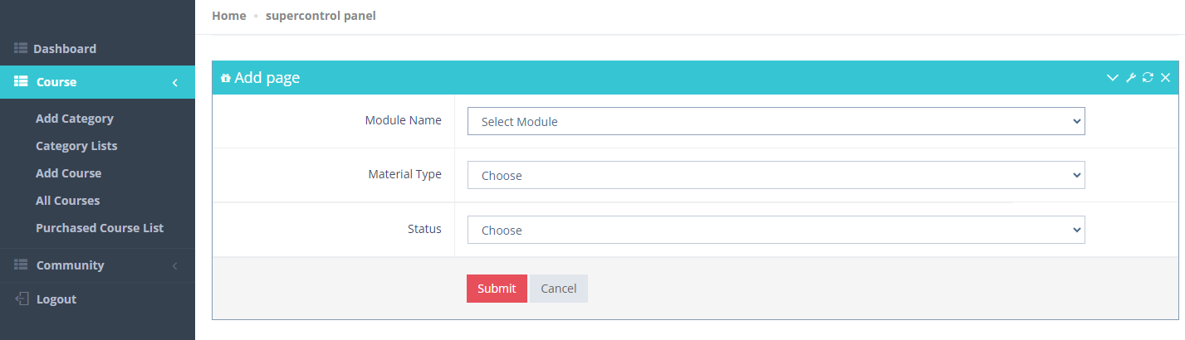

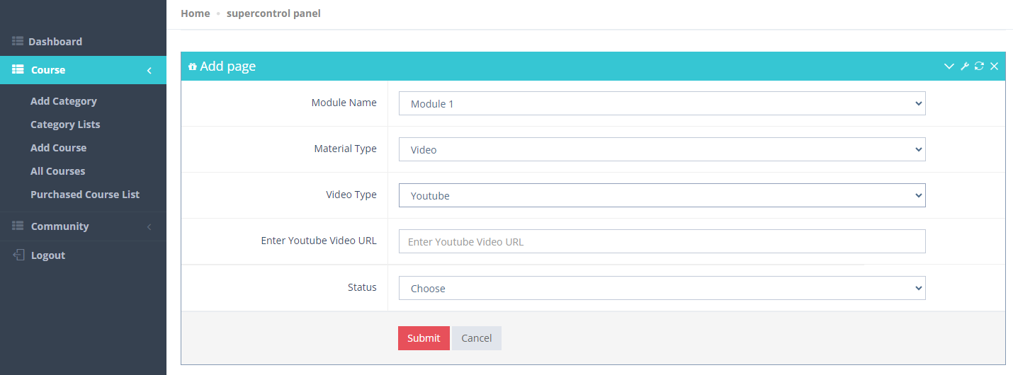

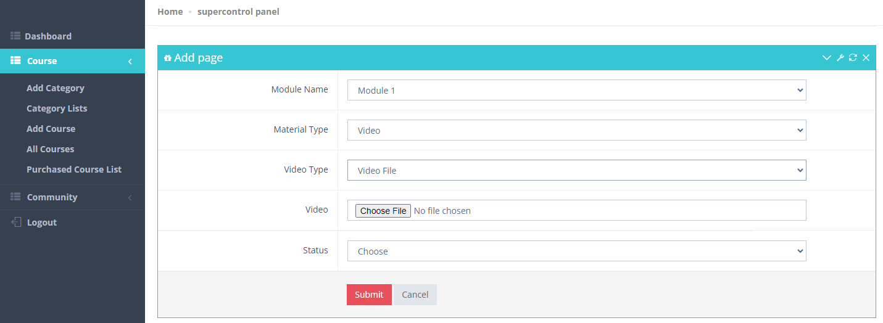

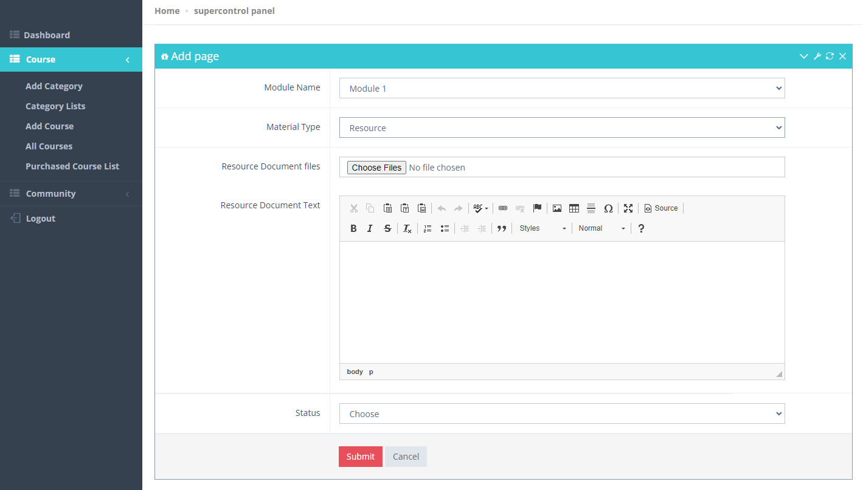

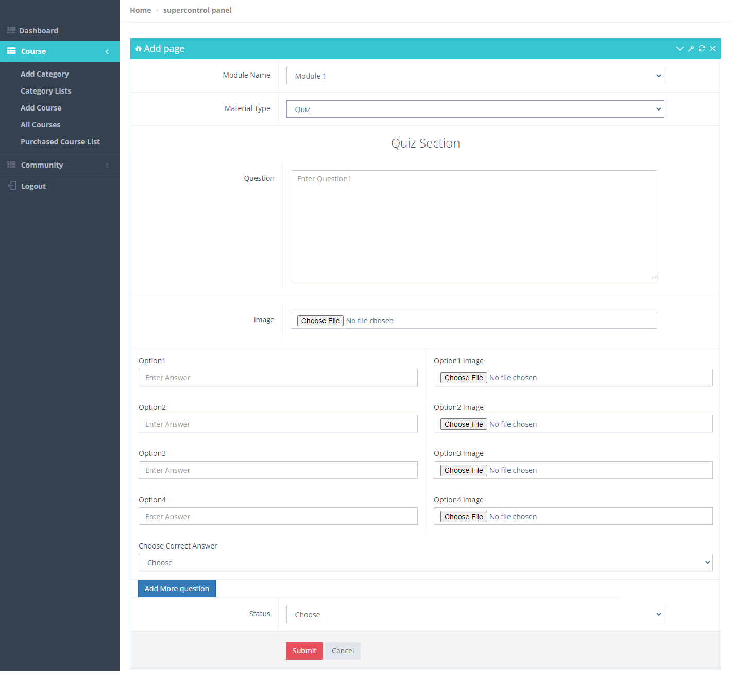

***Note: Instructor can add multiple quiz by clicking on the “Add More Question” button for each and every module.***

1. **Purchased Course**: All the purchase coursed will be listed here.

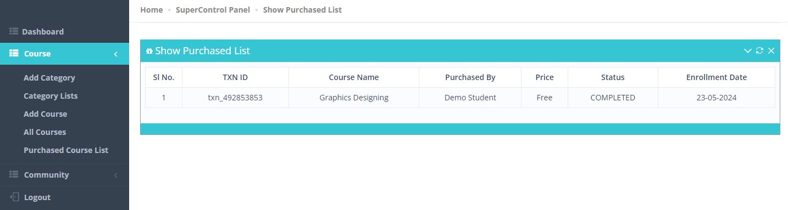

1. **Community**:
2. **Add Community**: Instructor can add community separately or course specific.

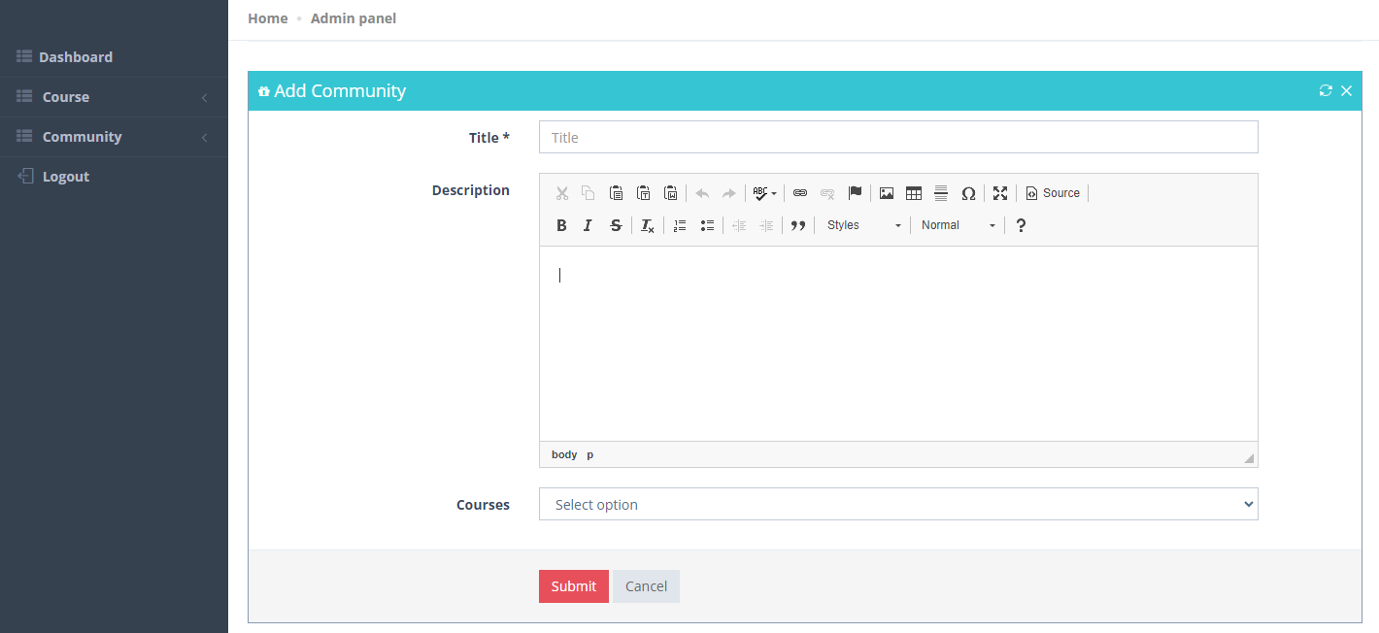

1. **Community List**: Added community will be listed here.

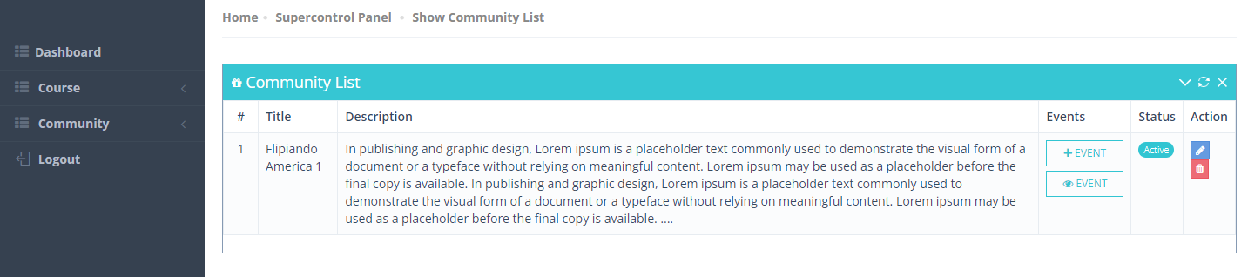

1. **Community Event Add**: Instructor can add community event based on each community.

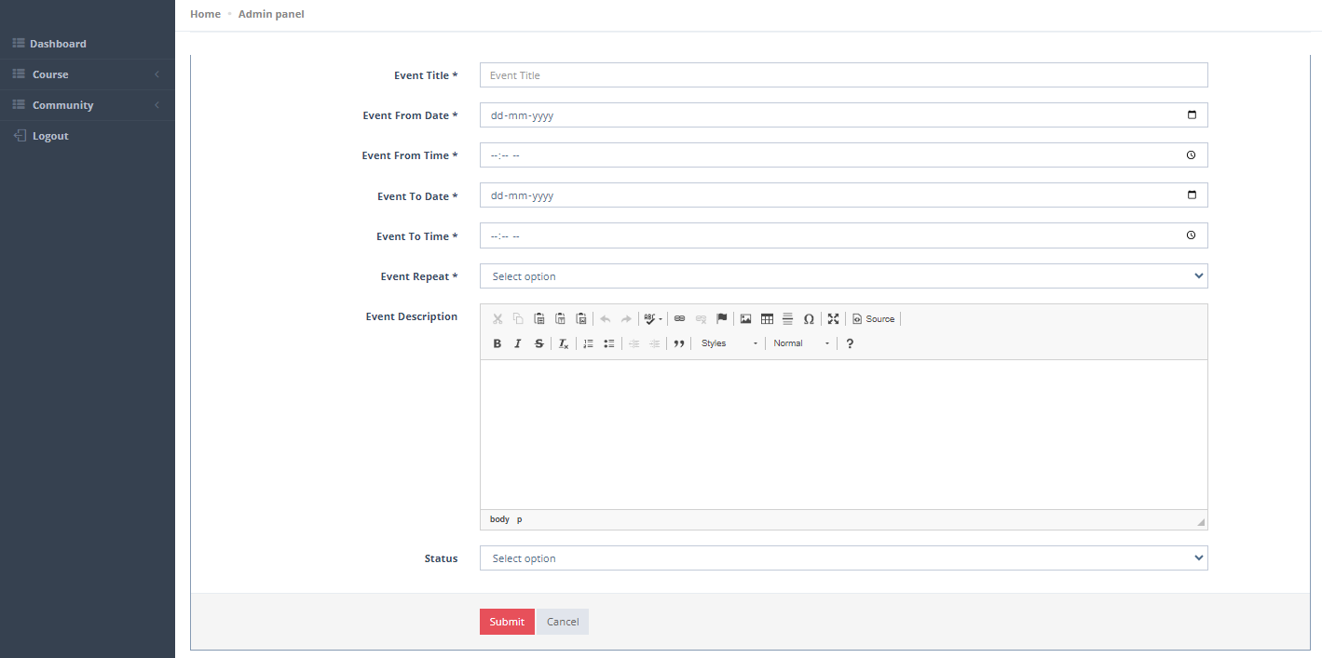

1. **Community Event View:** Instructor can view existing community event here also update and delete.

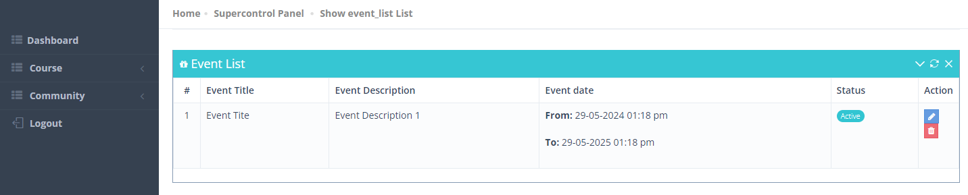

***NOTE: All the data showing in the screenshot are taken from development server.***